The 36th Japan-Korea International Seminar on Ceramics Abstract

Presenting AUTHOR¹, Second AUTHOR², Third AUTHOR^{1∗}
¹Department of Materials Science and Engineering, City, State ZIP-code, Country
²Department of Ceramics, City, State ZIP-code, Country

∗jkceramics36_example@chem.tottori-u.ac.jp (Corresponding author’s e-mail address)

Keywords: Materials, Process, Property, Structure, Ceramics (min. 3 words, Max. 5 words)

This is an instruction/template for preparing the abstract. Please submit abstracts in PDF file format.
Title, authors, and affiliations; Title must be bolded and centered (Times New Roman, 14 points). The presenting author’s name must be underlined. Family name should be typed in CAPITAL letters, and state all author(s) name(s) and affiliations including city, state/province and country (Times New Roman, 12 points). If the affiliations of the other authors are different from the first author, designate affiliations of all authors. Keywords should be within 5 terms. All papers must be written in English.
Contents; Margins are chosen as 2.5cm (1”) for top, bottom, right and left. All information including figures and/or tables must fit on 1 page in A4 paper. Text should be typed single-spaced (Times New Roman, 11 points). File name of the abstract should be typed as “AUTHOR’S LASTNAME-Initials” (ex.: KIM-TK.pdf) Abstract should be written in English and its volume should be 1 page. Figures can be included as shown in Fig. 1.
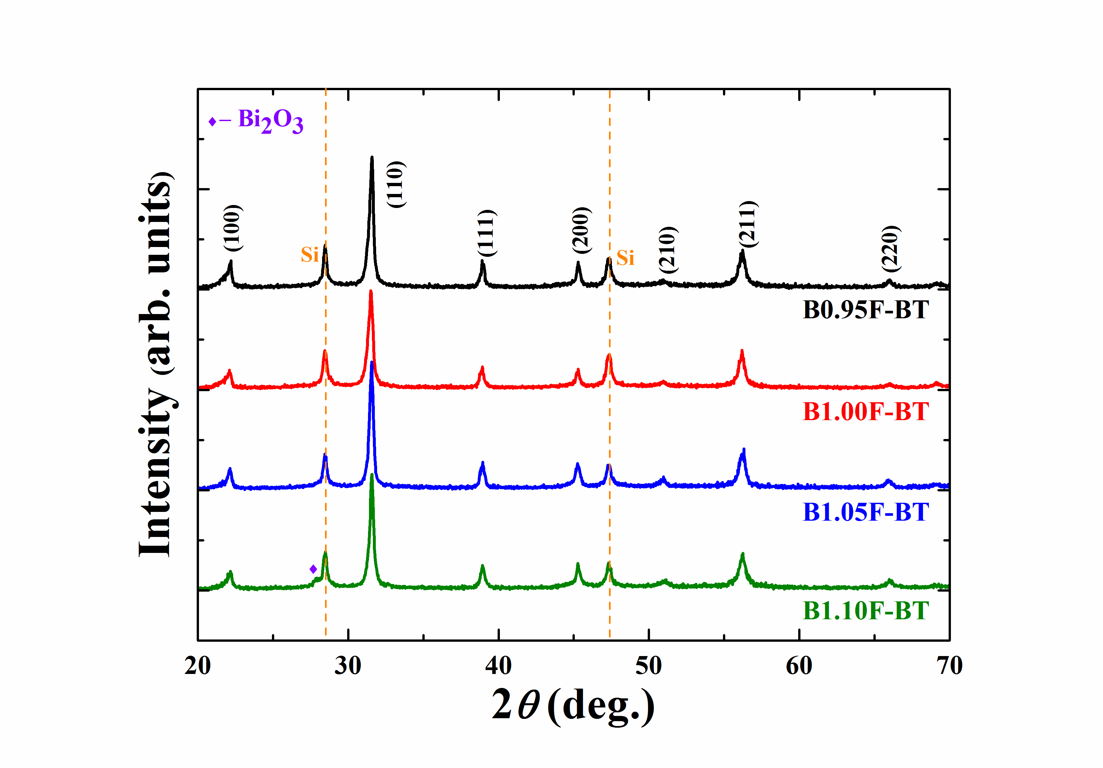
Figure 1 Included figure example with caption.(11 pt.)

References:

[1] T. Japan and H. Korea, J. Am. Ceram. Soc. 86 (2007) 10.
[2] T. Japan and H. Korea, Proc. of the 27th J-K Seminar on Ceramics (2010) p. 10.

Acknowledgement:

